Communicating in an Organizational Context
In addition to having the proper skills, you need to learn how to apply those skills in the business environment, which can be quite different from the social and scholastic environments you are accustomed to. Every organization has a formal communication network, in which ideas and information flow along the lines of command (the hierarchical levels) in the company’s organization structure (see Figure 1.4).

Figure 1.4
Formal Communication Network
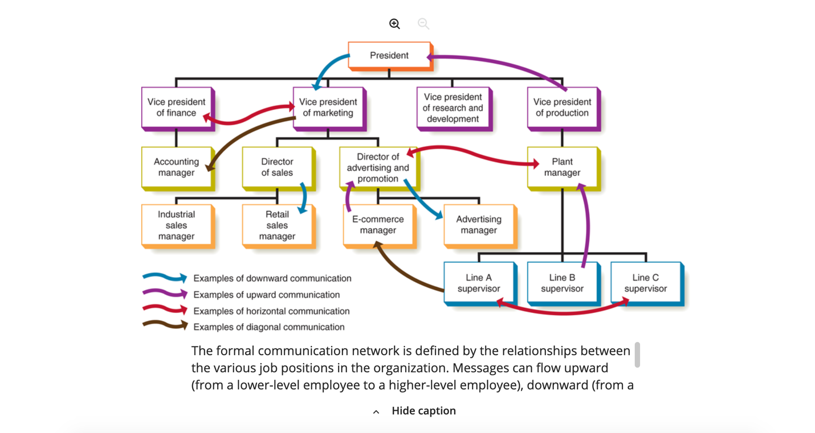

The formal communication network is defined by the relationships between the various job positions in the organization. Messages can flow upward (from a lower-level employee to a higher-level employee), downward (from a higher-level employee to a lower-level employee), horizontally (across the organization, between employees at the same or similar levels), or diagonally (across departments and upward or downward).
Figure 1.4 Full Alternative Text
Throughout the formal network, information flows in four directions.

Downward communication flows from top executives to middle managers to frontline employees, conveying executive decisions and providing information that helps employees do their jobs.

Upward communication flows from employees to middle managers and from middle managers to top executives, giving those at high levels insight into problems, trends, opportunities, grievances, and performance.

Horizontal or lateral communication flows between departments to help employees share information, coordinate tasks, and solve complex problems.

Finally, with diagonal communication, information crosses department lines while moving up or down.6 When problems and opportunities span multiple departments, horizontal and diagonal flows can help ensure that communication doesn’t get stifled moving up and down the vertical lines in the organization chart.7
Every organization also has an informal communication network, which encompasses all communication that occurs outside of formal channels. Some of this informal communication takes place naturally when employees interact on the job and in social settings, and some of it takes place when the formal network doesn’t provide information that employees want. In fact, the limitations of formal communication networks helped spur the growth of social media in the business environment. Communication in the informal network is healthy and important, because the formal network can’t always capture and share all the information that helps people do their jobs. However, if a workplace is rife with rumors and company gossip, this situation could be a sign that the formal network is not functioning effectively.

